X LIMIT LEFT CABLE

- PARTS:

QUANTITY: PART #: NOMENCLATURE: LENGTH:

2 PER MACHINE 17511-1 TERMINAL, QUICK DISCONNECT N/A

2 PER MACHINE 19108- WIRE, 22 AWG, GRAY 42 INCHES

1 PER MACHINE 17585-1 HOUSING, 2-PIN N/A

2 PER MACHINE 18729- TERMINAL, CRIMP, GOLDPLATE N/A

1 PER MACHINE 46776- SLEEVE, ¼” BLACK 41 INCHES

- ASSEMBLY:

- SLIDE THE WIRES INTO THE SLEEVING.

- STRIP 1/8 INCH FROM THE END OF THE WIRE PAIR.

- CRIMP AND TIN GOLD-PLATED TERMINALS TO THE STRIPPED WIRE ENDS, ACCORDING TO DIAGRAM 1.

- INSERT THE CRIMPED WIRES INTO THE HOUSING, ACCORDING TO DIAGRAM 2.

- STRIP ¼ INCH FROM THE OPPOSITE ENDS OF THE WIRE PAIR.

- CRIMP TWO QUICK-DISCONNECT TERMINALS TO THE STRIPPED WIRE ENDS.

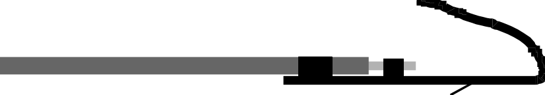

DIAGRAM 1



DIAGRAM 2

